## Merchant

Demo date: 8/20/24  
Scoping start date: 9/5/24

MSA Signature Date: 11/27/24  
Onboarding Kick Off Date: TBD

[If Exists] Opt Out Date: 5/27/25  
Go Live Date:

GTM POC: Rebecca  
Implementation POC: Royce

ERP: QBO

Tax Integration: No Tax

### 

### Key people at Merchant

* Aditi Bhatia - VP Finance & Ops
* Mike Mumma - Director Strategy & Ops

### 

| Notes Sections [Ops International Team to Ignore] *(AE/ Implementation to fill)*   * Tiered usage; 2-3 different event types; sometimes have minimums * Is there any important merchant relationship information?  1) What is the merchant temperament?   + Really excited, went dark for a while but finally got them to re-engage   2) Is there a key POC: (i.e.: who is the buyer/decision maker?)   * Aditi is the major decision maker. It seems like Mike was historically helping her with usage based billing, but he hasn’t been involved in the deal process since the demo   3) What are the Tabs features that the key POC cares about?   * Usage ingest (will want to set up the report scheduled to send from Looker) * Invoice calculation and sending * Reporting |
| --- |

### 

### Company summary *(AE to fill)*

Capitalize helps individuals take control of their retirement savings by simplifying the process of rolling over old 401(k) accounts into individual retirement accounts (IRAs). The platform is designed to minimize the complexity and paperwork typically associated with this process.

Goals (North star)  
*(AE/ Implementation to fill)*

What is the merchant's goal? What pain are we solving? Why are they buying Tabs?

* Automate calculations of usage based invoices
* Ingest all contracts and manage all the unique rates, minimums, etc.

Is there an opt out clause? If so, what is the merchant looking for so they do not exercise it?  
- Six month opt out; largely because the custom demo we did was only 2 contracts with no real usage data, and they just want to make sure we have a good way to support their usage needs

### Billing model *(AE/ Implementation to fill)*

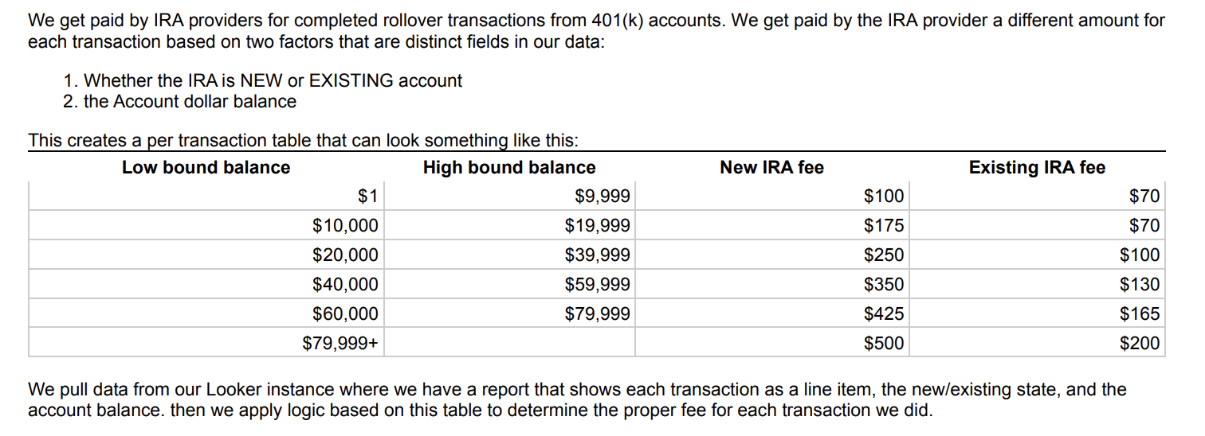

### Contract Processing Steps *(Implementation/Success to fill)*

1. Steps to process

**View the screenshot of sheet below, Capitalize is usage only. They will send a monthly Looker report, there are some slight adjustments that Tabs needs to do to configure to our settings. Adjustments required are listed in Green.** [**Capitalize Looker Usage Report Ingest Example**](https://docs.google.com/spreadsheets/d/1eMIoh2ZZS1mW4xYq_LRhETKvn8z7BbxVIeIiMKiSiNg/edit?usp=sharing)

**They have very few customers so no contracts tend to come through**

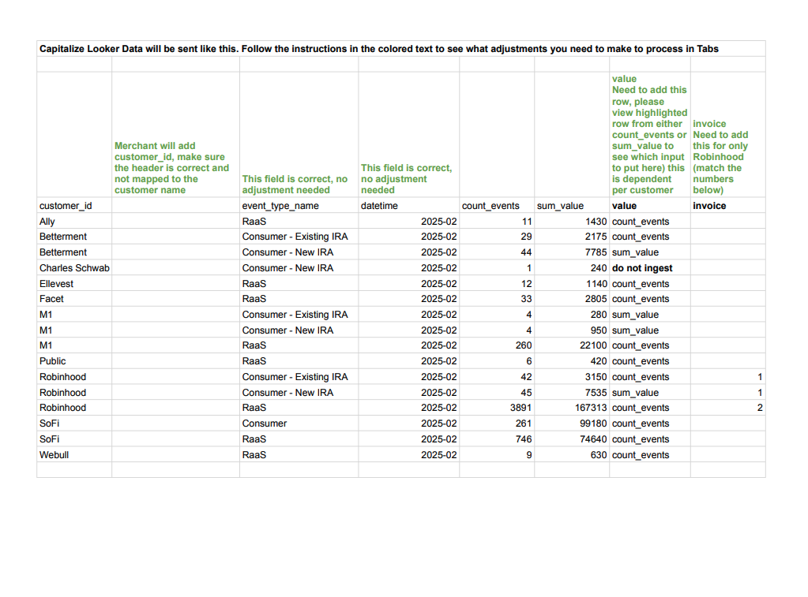

1. Anything to ignore in contracts?
2. Specifics processing things the merchant has requested that may differ by contract (e.g. always back-date invoice date to final day of the month)
3. Default Service Term
   1. If None Listed, Ops Default is 1 Year
4. Default Net Payment Terms
   1. If None, Ops Default is 0
5. Default Billing Frequency
   1. If None Listed, Ops Default is Monthly
6. How do we handle taxes as a line item?
   1. If None Listed, Ops Default is every tax line item becomes a BT

### Events Processing (if necessary) *(Implementation/Success to fill)*

* Any important information on events billing

Integration Items Processing (if necessary)  
*(Implementation/Success to fill)*

* What are the instructions for assigning integration items?
* Example: All Statsig integrations items should be labeled as “Sales”
* Example: All “Pinata” integration items should be labeled as “Software Subscription Bundle” unless otherwise noted by Merchant

Post Processing Communications (if necessary)  
*(Implementation/Success to fill)*

* Does the Ops Team need to notify anyone on the team re: completion of processing batches in Implementation or Active phase?
* Who needs to be notified and when?
  + Example:
    - Who: Customer Success [Azmat Aziz] needs to be notified
    - Where: Messari internal merchant channel
    - When: contracts are processed [Merchant Phase: Active]

### Customer Information *(Implementation/Success to fill)*

* Any important information on specifics customers of this merchant
  + Special memo’s certain invoices require
  + Invoice changes due to merchant/customer relationship

### Feature Requests *(AE/Implementation/Success to fill)*

* FR 1
  + What is it
  + Why it's important
  + Urgency

### Rewatch Calls *(AE/Implementation/Success to fill)*

​​[Call 1](https://tabs.rewatch.com/video/xp6xzk21kzg2tkrh-tabs-intro-august-20-2024)

[Call 2](https://tabs.rewatch.com/video/sxuenju4r738t0ol-capitalize-tabs-custom-demo-september-5-2024)

[Custom Demo](https://tabs.rewatch.com/video/ax8a8d8mgkysk00u-capitalize-tabs-custom-demo-path-forward-september-11-2024)